**Experiment No – 5**

**Aim :** Implementation of income tax/loan EMI calculator and deploy the same on real devices.

**CODE:**

**MainActivity**

package com.example.emicalculator;

import androidx.appcompat.app.AppCompatActivity;

import android.os.Bundle; import android.view.View; import android.widget.Button; import android.widget.EditText; import android.widget.Toast;

public class MainActivity extends AppCompatActivity { EditText P, N, _R;

Button submit;

@Override

protected void onCreate(Bundle savedInstanceState) { super.onCreate(savedInstanceState); setContentView(R.layout.activity_main);

P = findViewById(R.id.p); N = findViewById(R.id.n);

_R = findViewById(R.id.r);

submit = findViewById(R.id.submit);

submit.setOnClickListener(new View.OnClickListener() {

@Override

public void onClick(View view) { try {

int p = Integer.parseInt(P.getText().toString()); int n = Integer.parseInt(N.getText().toString()); int _r = Integer.parseInt(_R.getText().toString()); double r = (float) _r / 100.0;

double t = Math.pow(1 + r, n); Toast.makeText(MainActivity.this, "Value of EMI:" +

String.valueOf(Math.round( p * r * (t / (t - 1)))), Toast.LENGTH_SHORT).show();

} catch (Exception e){

Toast.makeText(MainActivity.this, "Something went wrong", Toast.LENGTH_SHORT).show();

}

}

});

}

}

**activity_main.xml:**

<?xml version="1.0" encoding="utf-8"?>

<LinearLayout xmlns:android="<http://schemas.android.com/apk/res/android>" xmlns:tools="<http://schemas.android.com/tools>" android:layout_width="match_parent" android:layout_height="match_parent"

tools:context=".MainActivity" android:orientation="vertical">

<EditText android:layout_width="match_parent" android:layout_height="wrap_content" android:id="@+id/p" android:inputType="number" android:hint="Enter the Value of P"/>

<EditText android:layout_width="match_parent" android:layout_height="wrap_content" android:id="@+id/n" android:inputType="number" android:hint="Enter the Value of N"/>

<EditText android:layout_width="match_parent" android:layout_height="wrap_content" android:id="@+id/r" android:inputType="number"

android:hint="Enter the Value of R[1..100]"/>

<Button android:id="@+id/submit"

android:layout_width="match_parent" android:layout_height="wrap_content" android:text="@string/calculate" tools:text="Calculate" />

</LinearLayout>

**OUTPUT:**

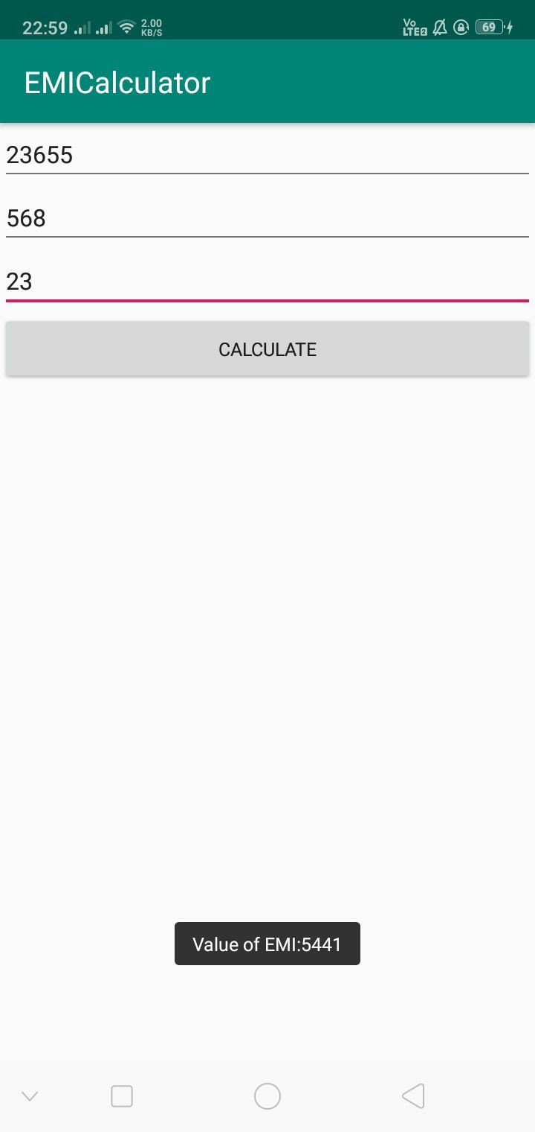

Conclusion : We have sucessfully implemented the program to calculate EMI